Mapping Musical Genres as a Similarity Network Using Spotify Audio Features
Muhsin Efe Tarım

Abstract
In this study, we analyze the structural organization of musical genres using a network-based approach derived from Spotify audio features. By representing each genre as a feature vector based on aggregated track-level characteristics, we construct a similarity network where edges indicate high cosine similarity between genres. We investigate the resulting network using centrality measures, clustering coefficients, and community detection algorithms. Our findings reveal a strong modular structure with six distinct genre communities corresponding to major musical styles such as acoustic, electronic, and rock-based genres. Furthermore, we examine the relationship between network centrality and genre popularity, finding no strong positive correlation. These results suggest that musical genres form continuous regions in an audio-feature space, and that popularity is driven more by external cultural factors than by intrinsic structural similarity.

Keywords: Network Science, Music Networks, Spotify Audio Features, Community Detection, Centrality Analysis, Genre Similarity

1. Introduction
Musical genres are commonly treated as discrete and well-defined categories. However, in practice, genres often overlap, evolve, and share stylistic characteristics. With the increasing availability of large-scale music datasets and audio descriptors, it has become possible to study genre relationships quantitatively.
Previous studies in Music Information Retrieval (MIR) have explored the use of audio features and similarity measures to analyze relationships between musical pieces, genres, and listening patterns [7,8]. These studies demonstrate that quantitative audio descriptors can provide meaningful representations of musical similarity and support clustering and classification tasks.
Network science provides a powerful framework to represent such relationships. Instead of viewing genres as isolated labels, they can be modeled as nodes in a network, where edges encode similarity based on measurable attributes.
Building upon these ideas, this study constructs a genre similarity network using Spotify audio features and addresses the following research questions:

RQ1: Do musical genres form meaningful clusters based on audio features?
RQ2: Which genres occupy central or bridging positions in the network?
RQ3: How does structural centrality relate to genre popularity?

2. Dataset
We use a Spotify dataset consisting of 114,000 tracks across 114 musical genres. Each track is associated with a set of audio features, including:
- danceability: Danceability describes how suitable a track is for dancing based on a combination of musical elements including tempo, rhythm stability, beat strength, and overall regularity. A value of 0.0 is least danceable and 1.0 is most danceable
- energy: Energy is a measure from 0.0 to 1.0 and represents a perceptual measure of intensity and activity. Typically, energetic tracks feel fast, loud, and noisy. For example, death metal has high energy, while a Bach prelude scores low on the scale
- loudness: The overall loudness of a track in decibels (dB)
- speechiness: Speechiness detects the presence of spoken words in a track. The more exclusively speech-like the recording (e.g. talk show, audio book, poetry), the closer to 1.0 the attribute value. Values above 0.66 describe tracks that are probably made entirely of spoken words. Values between 0.33 and 0.66 describe tracks that may contain both music and speech, either in sections or layered, including such cases as rap music. Values below 0.33 most likely represent music and other non-speech-like tracks
- acousticness: A confidence measure from 0.0 to 1.0 of whether the track is acoustic. 1.0 represents high confidence the track is acoustic
- instrumentalness: Predicts whether a track contains no vocals. "Ooh" and "aah" sounds are treated as instrumental in this context. Rap or spoken word tracks are clearly "vocal". The closer the instrumentalness value is to 1.0, the greater likelihood the track contains no vocal content
- liveness: Detects the presence of an audience in the recording. Higher liveness values represent an increased probability that the track was performed live. A value above 0.8 provides strong likelihood that the track is live
- valence: A measure from 0.0 to 1.0 describing the musical positiveness conveyed by a track. Tracks with high valence sound more positive (e.g. happy, cheerful, euphoric), while tracks with low valence sound more negative (e.g. sad, depressed, angry)
- tempo: The overall estimated tempo of a track in beats per minute (BPM). In musical terminology, tempo is the speed or pace of a given piece and derives directly from the average beat duration
- duration: The track length in milliseconds
Although both features relate to vocal content, they capture different aspects of a track. Speechiness measures the presence of spoken words, whereas instrumentalness estimates the likelihood that a track contains no vocals.

These features were selected because they represent Spotify’s standardized audio descriptors and capture different acoustic and perceptual dimensions of music, including rhythm, intensity, mood, vocal content, and acoustic characteristics. Together, they provide a compact representation of a genre’s overall acoustic profile, making them suitable for similarity analysis at the genre level.
Additionally, each track includes a popularity score ranging from 0 to 100. This score is provided by Spotify and reflects the relative popularity of a track based on factors such as streaming activity, user engagement, and recency. The popularity metric should be interpreted as a platform-level measure of exposure rather than a direct indicator of musical quality.
The dataset is balanced, with approximately equal representation of tracks per genre, ensuring unbiased aggregation at the genre level.

3. Methodology
3.1 Feature Preprocessing
Numerical audio features were standardized using z-score normalization in order to ensure comparability across features with different numerical scales.
3.2 Genre Representation

Each genre was represented by the mean feature vector obtained from all tracks belonging to that genre.

3.3 Similarity Computation

Pairwise cosine similarity was computed between genre feature vectors in order to quantify stylistic similarity between genres. Cosine similarity was selected because it measures the similarity of feature profiles based on their orientation in the feature space rather than their absolute magnitude. Since all audio features were standardized using z-score normalization, cosine similarity provides an effective way to compare the relative acoustic characteristics of genres.

3.4 Network Construction

We constructed an undirected weighted graph in which:

- Nodes represent musical genres

- Edges represent cosine similarity values above a threshold of 0.7

- Edge weights correspond to similarity scores

The threshold value was selected to balance network connectivity and structural interpretability. Although the original dataset contains 114 genres, the genre comedy became completely isolated at the selected similarity threshold (0.70) and therefore did not appear in the resulting graph representation. Consequently, the final network contains 113 nodes and 636 edges.
3.5 Network Analysis
We computed:
- Degree centrality
- Betweenness centrality
- Clustering coefficient
We also applied the Louvain algorithm for community detection. The Louvain community detection algorithm is inherently stochastic and may yield different partitions across runs. To ensure reproducibility, a fixed random seed (random_state = 3) was used, resulting in a stable partition with six communities, which is consistently used throughout the analysis.

3.6 Popularity Analysis
To analyze real-world impact, we computed:
- Average popularity per genre
- Correlation between popularity and centrality measures
Popularity values were treated as indicators of platform-level exposure and listener engagement rather than intrinsic musical quality.
3.7 Threshold Sensitivity Analysis
To evaluate the robustness of the network construction process, we examined how different similarity thresholds affect the overall structure of the network. Lower thresholds such as 0.60 and 0.65 produce highly dense networks with a single connected component, potentially reducing the interpretability of community structures. In contrast, higher thresholds such as 0.75 and 0.80 significantly decrease the number of edges and increase network fragmentation.

The threshold value of 0.70 was selected as a balance between connectivity and structural separation. At this threshold, the network contains 113 nodes and 636 edges, with a density of 0.1005 and an average degree of 11.26. Furthermore, the network remains largely connected, consisting of only two connected components and a giant component containing 110 nodes. These properties preserve meaningful genre relationships while avoiding the excessive density observed at lower thresholds and the fragmentation observed at higher thresholds, thereby supporting interpretable community detection and network analysis.
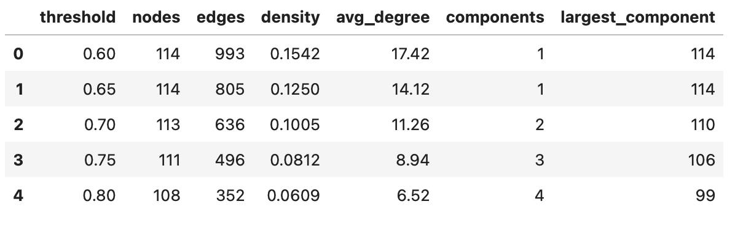 Table 1: Structural properties of the network under different similarity thresholds.

4. Results
4.1 Network Structure
The constructed genre similarity network consists of 113 nodes and 636 edges. The only genre excluded from the final graph representation was comedy, because it had no similarity connections above the selected threshold. The overall density of the network is 0.10, indicating a moderately connected structure. The average degree is approximately 11.26, suggesting that each genre is, on average, connected to multiple other genres based on feature similarity. Furthermore, the network is composed of two connected components, with one dominant giant component and a very small isolated component. For visualization clarity, the analysis primarily focuses on the largest connected component. The smaller component contains only a few genres and remains structurally disconnected from the main genre landscape at the selected similarity threshold. Since the objective of this study is to examine the overall organization of genre relationships, the main visual and structural interpretations primarily emphasize the giant component, while the smaller component is reported separately in the community detection results.
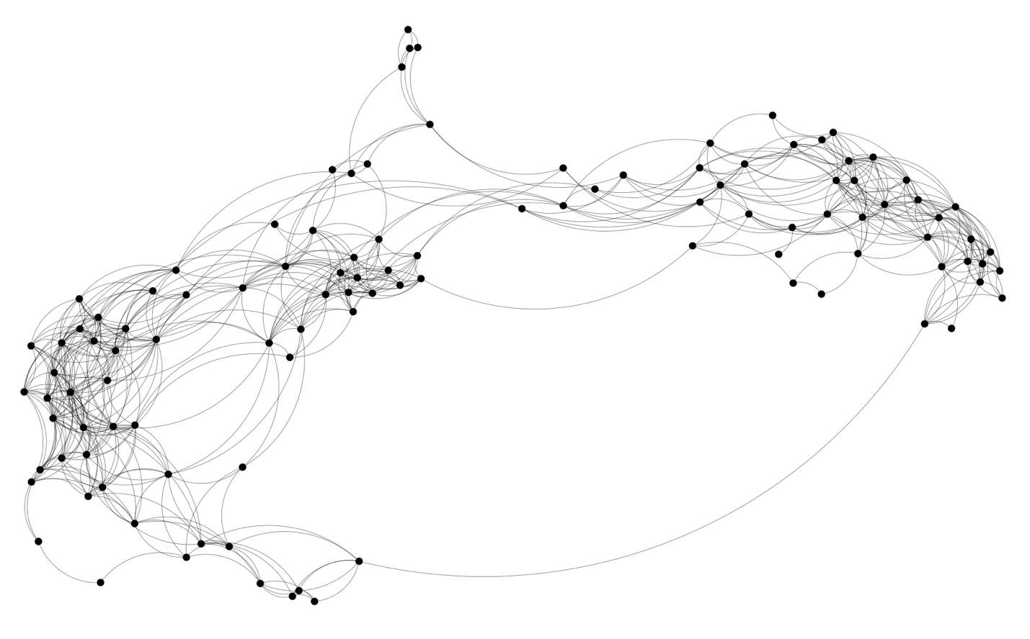
Figure 1: Overall structure of the genre similarity network. Nodes represent genres and edges indicate high similarity relationships. The visualization focuses on the largest connected component.
4.1.1 Degree Distribution
Figure 2 shows the degree distribution of the genre similarity network. Most genres exhibit moderate degree values, while a smaller number of genres possess relatively high degree values, indicating the presence of several highly connected hub-like genres. This distribution suggests that although the network does not exhibit extreme scale-free characteristics, certain genres occupy structurally central positions within the similarity space.
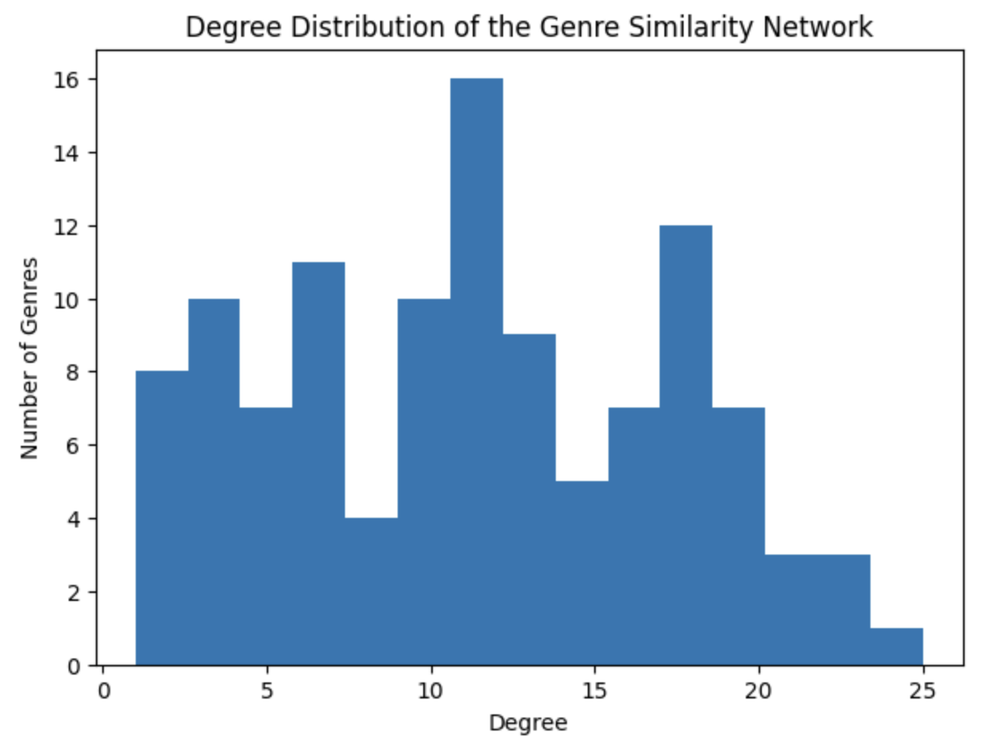
Figure 2: Degree distribution of the genre similarity network.

4.2 Centrality Analysis
To understand the structural importance of genres within the network, we analyze centrality measures, focusing on degree and betweenness centrality.

Genres with the highest degree centrality include industrial, alternative, metal, and metalcore. These genres are highly connected within the network, indicating that they share audio characteristics with a wide range of other genres. This suggests that such genres occupy central positions in the feature space and may represent stylistically flexible or hybrid musical categories, as illustrated in Figure 3.
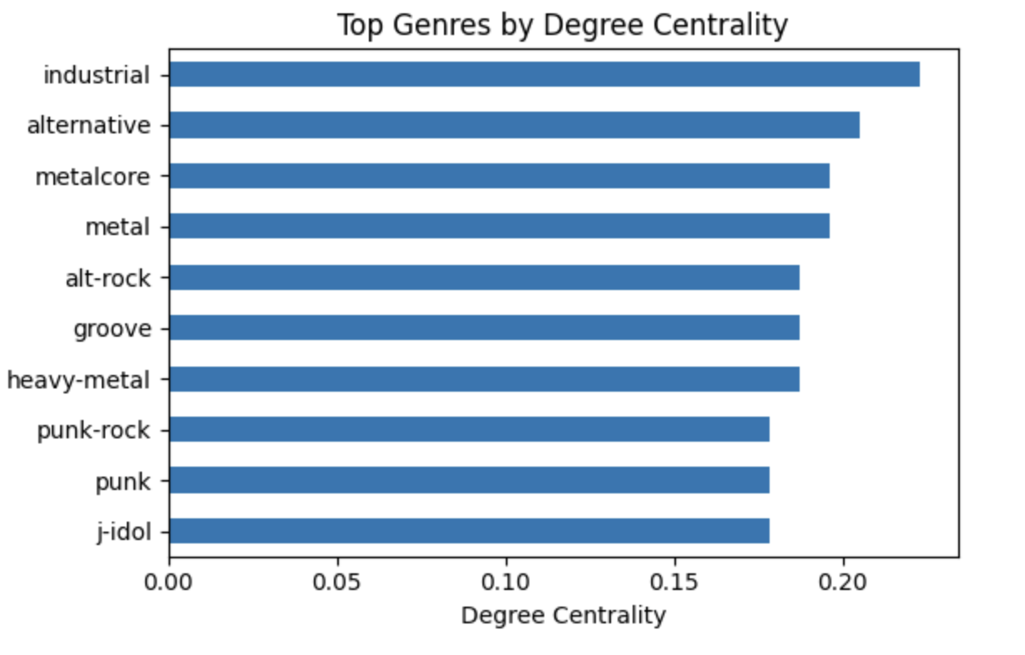
Figure 3: Top genres ranked by degree centrality.

In contrast, betweenness centrality highlights genres that act as bridges between different parts of the network. The genres with the highest betweenness centrality include minimal-techno, pop, country, and breakbeat. These genres play a crucial role in connecting otherwise distant regions of the network, facilitating transitions between stylistically distinct clusters, as shown in Figure 4.
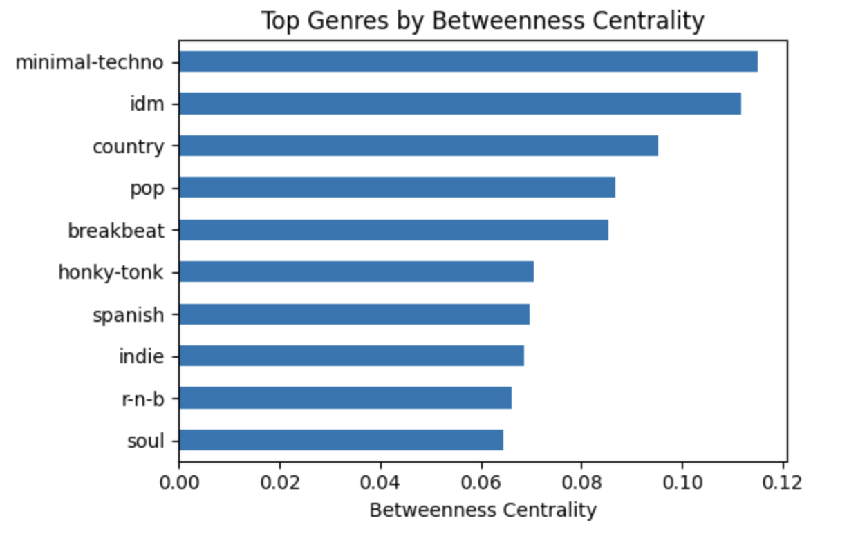
Figure 4: Top genres ranked by betweenness centrality.

This distinction between highly connected genres and bridging genres reveals different structural roles within the network. While high-degree genres are embedded within densely connected regions, reflecting strong similarity with many other genres, high-betweenness genres tend to appear at the boundaries between communities, acting as connectors across otherwise separated clusters. This structural difference is clearly illustrated in Figure 5, where high-degree genres are concentrated within dense clusters, whereas high-betweenness genres occupy transitional positions linking different communities.
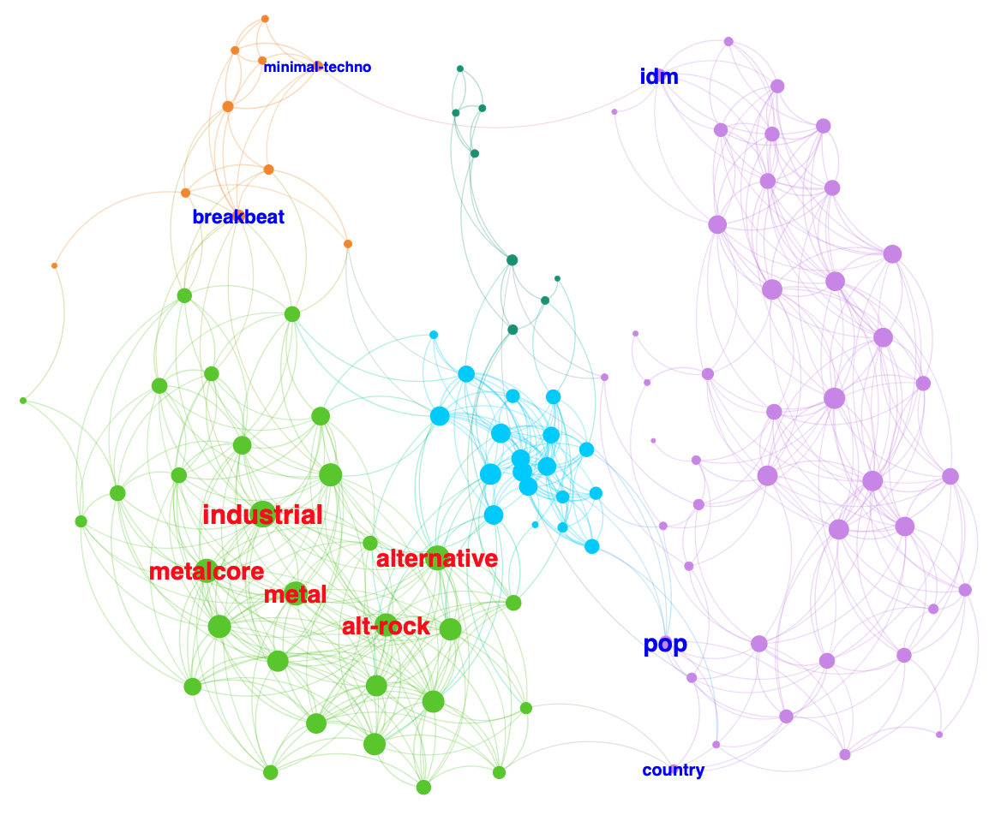
Figure 5: Centrality roles in the genre similarity network. Red labels indicate genres with high degree centrality located within dense clusters, while blue labels represent genres with high betweenness centrality positioned at the boundaries between communities.

4.3 Community Detection
The Louvain community detection algorithm identifies 6 communities with a modularity score of 0.61, indicating a well-defined and highly modular structure within the genre similarity network. As shown in Figure 6, the distribution of nodes across communities is heterogeneous, consisting of both large densely connected clusters and smaller specialized groups.

Community PURPLE is the largest cluster, containing approximately 38.05% of all genres (43 nodes). This community primarily includes acoustic-oriented genres such as acoustic, ambient, blues, and related styles, reflecting a region characterized by lower energy and higher acousticness values.

The second largest group, Community GREEN (26.55%, 30 nodes), contains genres such as alt-rock, alternative, and various metal subgenres including black metal and death metal. This cluster forms a dense and highly interconnected region associated with higher energy and loudness.

Community CYAN (16.81%, 19 nodes) represents dance-oriented genres including EDM, disco, and electro, suggesting a cluster with high danceability and rhythmic consistency.

Community ORANGE (8.85%, 10 nodes) includes genres such as breakbeat, club, and deep house, forming a transitional electronic cluster that connects multiple stylistic regions of the network.

Community DARK GREEN (7.08%, 8 nodes) contains genres such as afrobeat, salsa, and R&B-related styles, reflecting rhythmically rich and globally influenced musical characteristics.

Finally, Community PINK (2.65%, 3 nodes) is the smallest and most isolated cluster, consisting of highly specialized genres such as brazil, gospel, and world music, forming a loosely connected peripheral component.

Figure 7 further demonstrates that these communities differ substantially in their average audio feature profiles. Distinct variations in energy, acousticness, danceability, loudness, and instrumentalness indicate that the detected communities are not only structurally separated within the network but also acoustically meaningful.

Overall, the detected communities correspond to coherent musical groupings, where structural separation in the network aligns closely with differences in underlying audio characteristics.

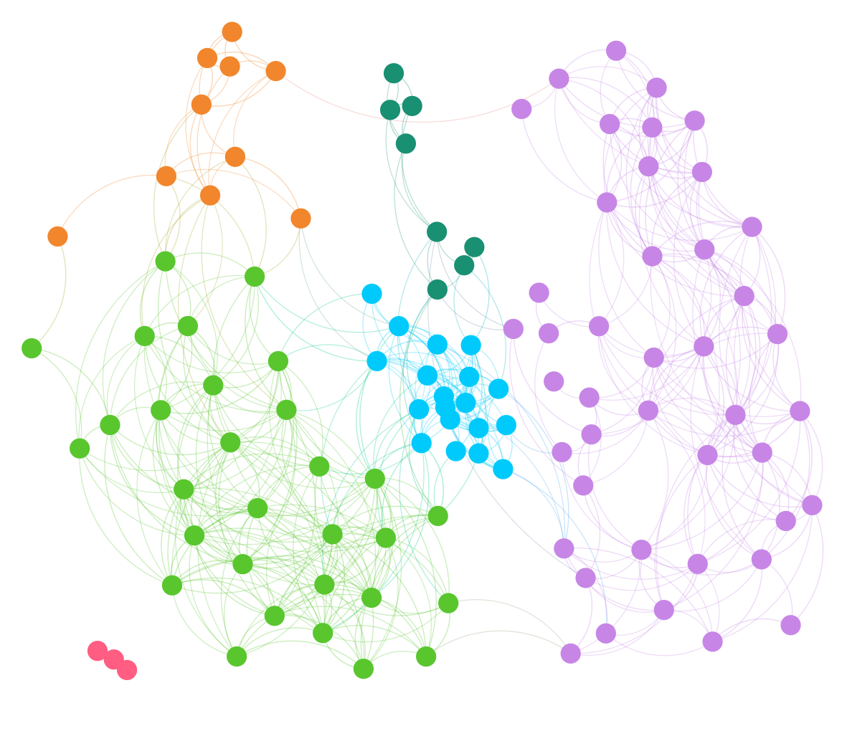
Figure 6: Community structure of the genre similarity network, where node colors represent Louvain communities and illustrate the modular organization of genres.

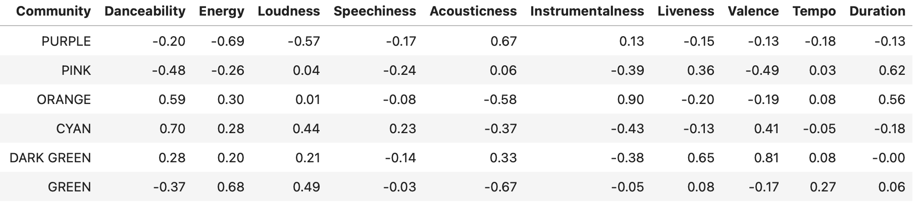
Figure 7: Average audio feature profiles of each community, highlighting distinct acoustic characteristics across genre clusters.
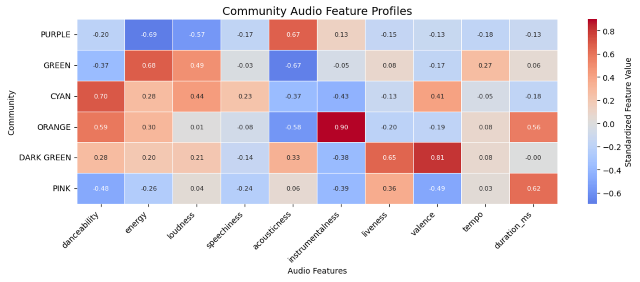
Figure 8: Heatmap of standardized audio feature profiles across detected communities. Warmer colors indicate above-average feature values, while cooler colors indicate below-average values.

4.4 Popularity vs Centrality
Correlation analysis reveals weak negative relationships between popularity and structural centrality measures. The correlation between popularity and degree centrality is −0.15, while the correlation between popularity and betweenness centrality is −0.19. These results suggest that structurally important genres are not necessarily the most popular genres within the dataset.
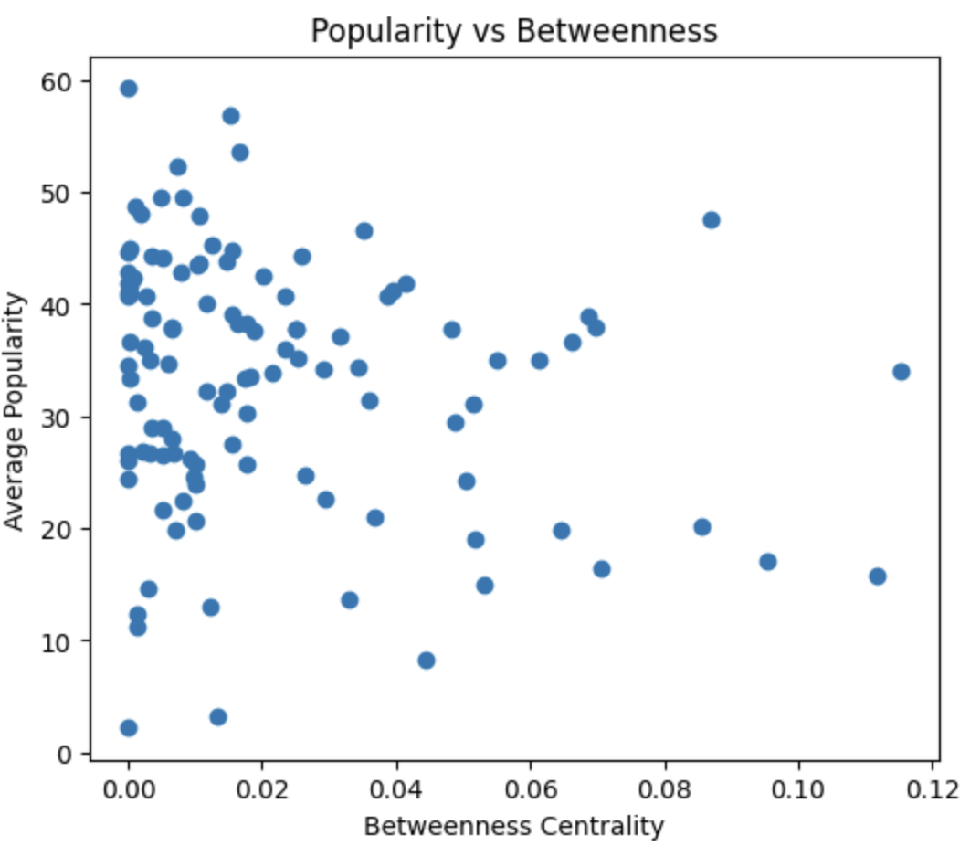
Figure 9: Relationship between popularity and betweenness centrality. The weak correlation indicates that highly popular genres are not necessarily structurally important bridge genres within the network.
4.5 Popularity Extremes
The most popular genres in the dataset include pop-film, k-pop, chill, sad, grunge, and pop. However, these genres do not necessarily occupy structurally central positions within the network. For example, genres such as pop-film and sad achieve very high popularity despite having relatively low degree and betweenness centrality values. This observation suggests that popularity and structural importance capture different aspects of the genre ecosystem.
To further investigate the relationship between structural position and real-world recognition, we examine the least popular genres in the dataset. Genres such as iranian, romance, latin, and detroit-techno exhibit very low average popularity scores despite occupying diverse structural positions within the network.

Notably, these genres do not correspond to the most peripheral or isolated regions of the graph. Some remain moderately connected to broader stylistic communities, while others occupy more specialized positions. This observation further supports the earlier correlation analysis, suggesting that structural centrality alone is not sufficient to explain genre popularity.

Overall, popularity appears to depend more strongly on external cultural, commercial, and historical factors rather than purely on audio-feature similarity or network position.

5. Discussion
Our findings demonstrate that musical genres are not isolated categories but instead form a continuous similarity space shaped by shared acoustic characteristics. The detected community structure reveals that genres naturally organize into coherent stylistic regions, including acoustic-oriented, electronic, and rock-based clusters.

Centrality analysis further suggests that structurally important genres often correspond to stylistically flexible or hybrid musical forms. Genres with high degree centrality are embedded within dense similarity regions, whereas genres with high betweenness centrality frequently act as bridges connecting otherwise distinct musical communities.

The weak relationship observed between popularity and structural centrality indicates that musical popularity cannot be explained solely through audio-feature similarity. Instead, popularity appears to depend more strongly on cultural exposure, commercial dynamics, recommendation systems, and temporal listening trends.

More broadly, this study illustrates how network science can provide interpretable representations of complex cultural systems. By modeling genres as interconnected entities rather than isolated labels, network-based approaches make it possible to reveal hidden structural relationships within large-scale musical datasets.

Future work could incorporate artist–genre bipartite relationships in order to investigate artistic versatility and cross-genre influence. Such an approach may help explain why certain genres occupy structurally important bridge positions within the network. Additional network metrics and statistical significance tests could also be incorporated to further validate the robustness of the observed structural patterns. Another potential application of the network is the identification of genre-transition paths, where listeners could be guided from a preferred genre to a target genre through intermediate genres that share similar audio characteristics.

6. Limitations
This study has several limitations. First, genre labels are predefined by the dataset and may contain subjective or overlapping categorizations, which can influence the resulting network structure. Second, representing each genre using averaged audio-feature vectors may obscure internal diversity and stylistic variation within genres. Genres often contain multiple substyles and heterogeneous musical characteristics, which cannot be fully captured by a single mean feature vector. As a result, some within-genre information may be lost during the aggregation process.

In addition, the selection of the similarity threshold directly affects network density, connectivity, and community structure. Although a threshold sensitivity analysis was performed, different threshold choices may lead to alternative structural interpretations.

Finally, popularity values are derived from Spotify platform dynamics and may reflect commercial exposure, recommendation algorithms, and temporal listening trends rather than purely musical characteristics.
7. Conclusion
We presented a network-based analysis of musical genres using Spotify audio features. The resulting similarity network reveals a strong modular structure, demonstrating that musical genres naturally form coherent clusters based on shared acoustic characteristics.

Centrality analysis further shows that some genres occupy highly connected hub-like positions, while others serve as bridges between otherwise distinct stylistic communities.

Importantly, we find that structural centrality is only weakly related to genre popularity, suggesting that listener behavior is shaped more strongly by cultural and commercial dynamics than by intrinsic audio-feature similarity.

The source code, preprocessing pipeline, and analysis scripts used in this study are publicly available at: https://github.com/EfeTarimmm

References:

1. Maharshipandya, “Spotify Tracks Dataset,” Kaggle, 2021. Available: https://www.kaggle.com/datasets/maharshipandya/-spotify-tracks-dataset
2. A.-L. Barabási, Network Science. Cambridge University Press, 2016.
3. C. D. Manning, P. Raghavan, and H. Schütze, Introduction to Information Retrieval. Cambridge University Press, 2008.
4. M. Bastian, S. Heymann, and M. Jacomy, “Gephi: An Open Source Software for Exploring and Manipulating Networks,” ICWSM, 2009.
5. A. Hagberg, P. Swart, and D. S. Chult, “Exploring Network Structure, Dynamics, and Function using NetworkX,” 2008.
6. V. D. Blondel, J.-L. Guillaume, R. Lambiotte, and E. Lefebvre, “Fast unfolding of communities in large networks,” Journal of Statistical Mechanics: Theory and Experiment, 2008.
7. M. Schedl, E. Gómez, and J. Urbano, “Music Information Retrieval: Recent Developments and Applications,” Foundations and Trends in Information Retrieval, vol. 8, no. 2–3, pp. 127–261, 2014.
8. K. Gurjar and Y.-S. Moon, “A Comparative Analysis of Music Similarity Measures in Music Information Retrieval Systems,” Journal of Information Processing Systems, vol. 14, no. 1, pp. 32–55, 2018.

